Names____________________________________ Date __/__/____ Period_____
Name of your colony ____________________________________________
Create Your Colony! 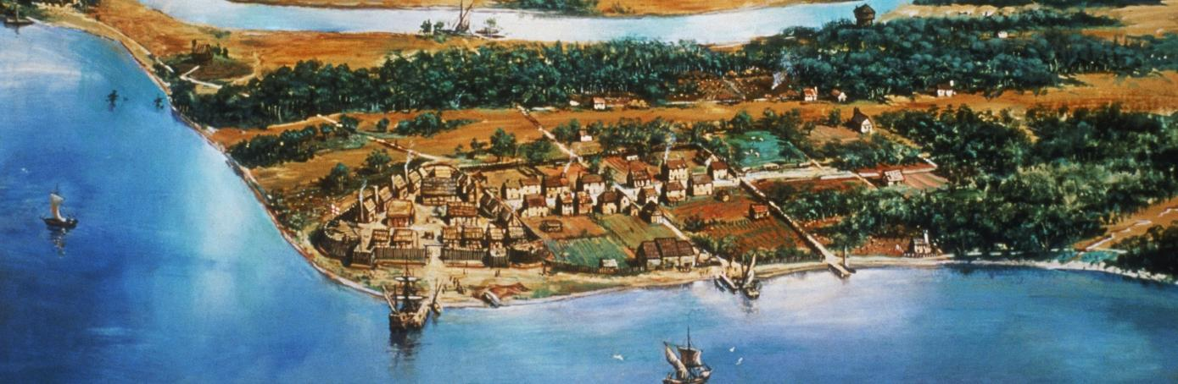
http://www.history.com/topics/jamestown
You are unhappy with your life in your current country and want to take your family to another part of the world to give you and your children a better life. After studying maps of the world with the textbook provided, you feel like you have found the perfect location. You have organized 2 ships with 50 people on each ship. For this activity you will work with a partner. DUE October 13, 2017
Make sure you complete ALL tasks so you don’t lose points!
This project will have 2 components:
1.) Draw and color your colony on 8 ½ X 14 copy paper
2.) Create a “Colony Contract” sheet that describes the purpose of your choice and what it would take to survive.
Resources:
World Map: 706-707, Climate maps: Pages 56-57, Physical Maps: North America (710), South America (712), Asia (716), Africa (718), Geographic Dictionary Pages H10 – H11
NCWiseOwl

Project Rubric

10 points ______ A. What type of ship will you travel in? How many passengers and crew? What supplies would you need on board ship to survive the journey?
10 points ______ B.Why did you choose this region of the world? Write 1 paragraph that includes the reason for this location, the terrain of the area, and the climate around your colony. What plants or animals would be found in this region?
5 points _____ C.What occupations would ensure your colony the greatest success? Why? Choose five occupations that would serve as leaders of the colony.
10 points _____List the 10 most important supplies your colony would need for success. (1 point each)
10 points _____ List 10 personal items you think each colonist should bring to ensure you the best chance of survival.
5 points ______Creativity/Neatness
Total __________
In addition you must answer the following questions to illustrate a deeper understanding of the concept of colonization and the difficulties faced. All answers must be answered in complete sentences.
- Research and report on 3 natural resources found in the vicinity of your colony. Of those three, which resource will make your colony the wealthiest? Explain what that resource would be for and how that would impact your colony as a whole. 10 points _____

- List three pros and cons of becoming a colonist. Explain your answers in detail. 10 points _____

Poster Rubric

5 points: _____Colony drawn neatly on 8 ½ X 14 copy paper in portrait view
10 points: _____Must include the following items within your poster
- Key with 5 symbols representing items within your drawing
- Pastures for grazing
- Stables
- Gardens
- At least 10 buildings
- Town square
- Well for water supply
- Roads and paths throughout the town
- Defensive wall and military installations.
- Your teacher’s House
5 points: _____Colorful
5 points: _____Region of the world will be shown in an insert in the lower right corner of the copy paper and must be labeled (ex: South America, North America etc.)
5 points: _____Name of your colony in large letters

Total ______________

