Assignment # _____ Name: ________________________
Date: _________________________
Period: _______________________
The Voyages of Alvise Cadamasto
Directions: Study the map entitled “Test Your Geography Skills” from our class presentation. Label each West African counrty on the map below from the word bank. Then, label the three (3) countries that Alvise Cadamasto discovered in the correct order. Simply label the countries 1, 2 and 3.

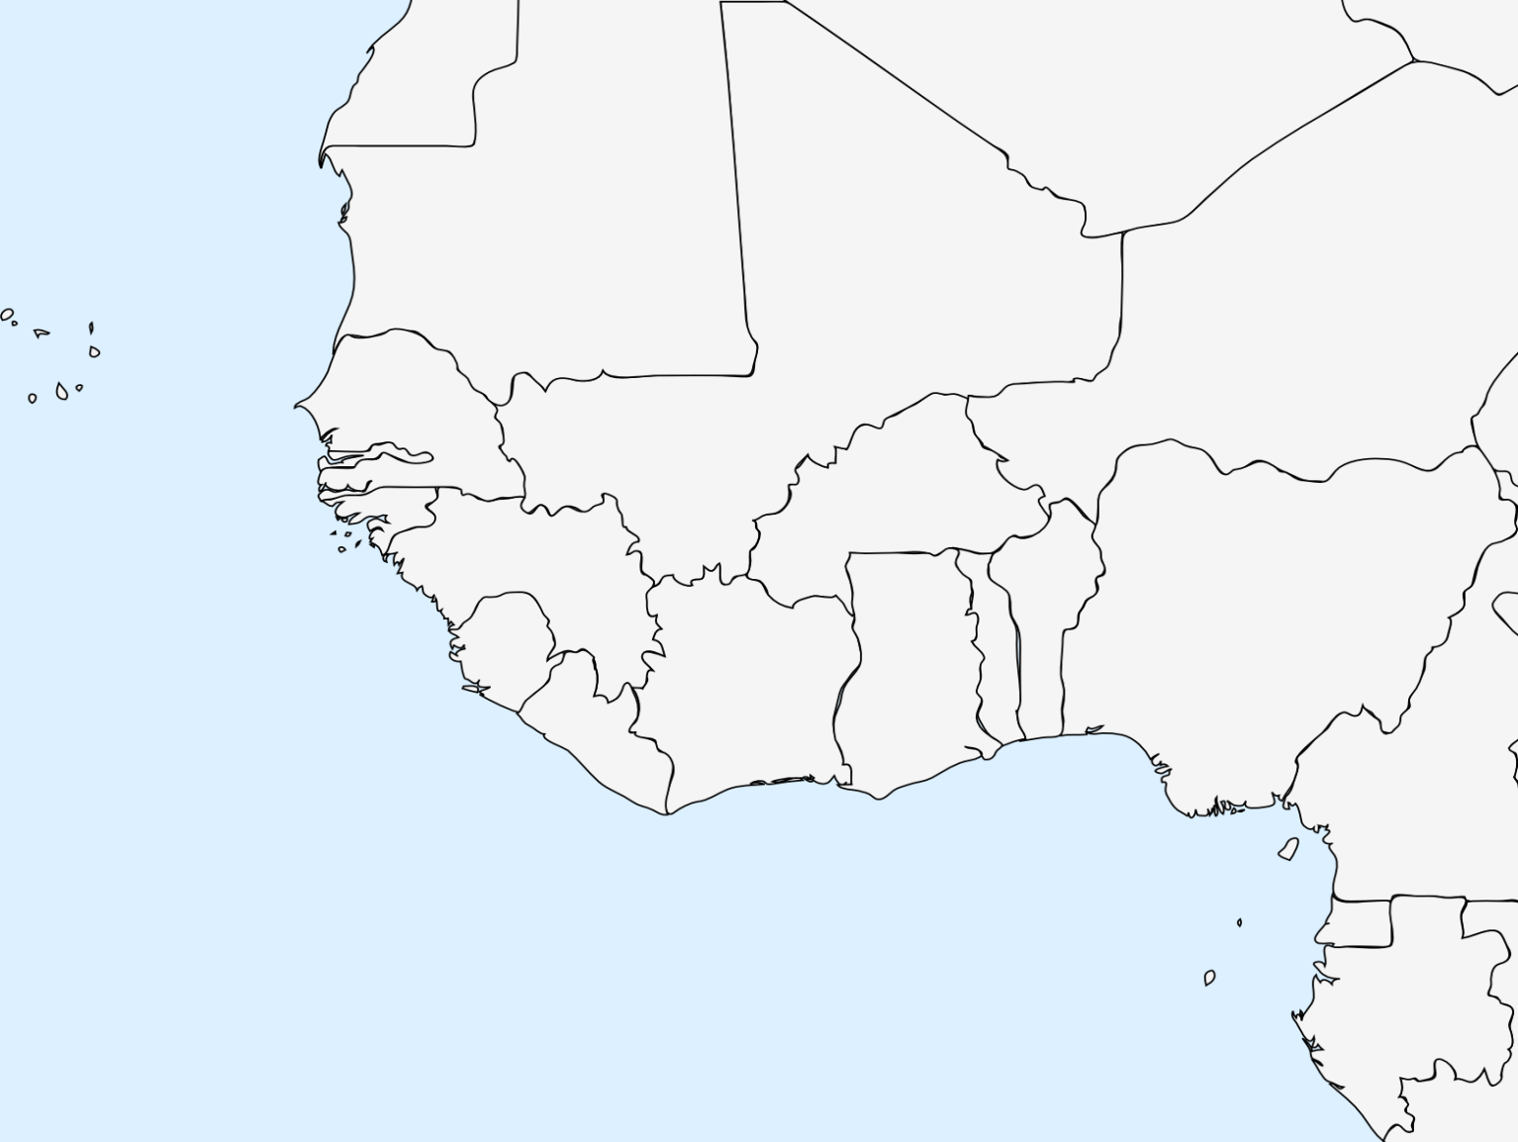
After labeling each country, color each one a DIFFERENT COLOR. Then, color all other unlabeled land in Africa BROWN.
- Benin 2) Cape Verde Islands 3) Burkina Faso
4) Gambia 5) Ghana 6) Guinea
7) Guinea Bissau 8) Ivory Coast 9) Liberia
10) Mali 11) Mauritania 12) Niger
13) Nigeria 14) Senegal 15) Sierra Leone
16) Togo

